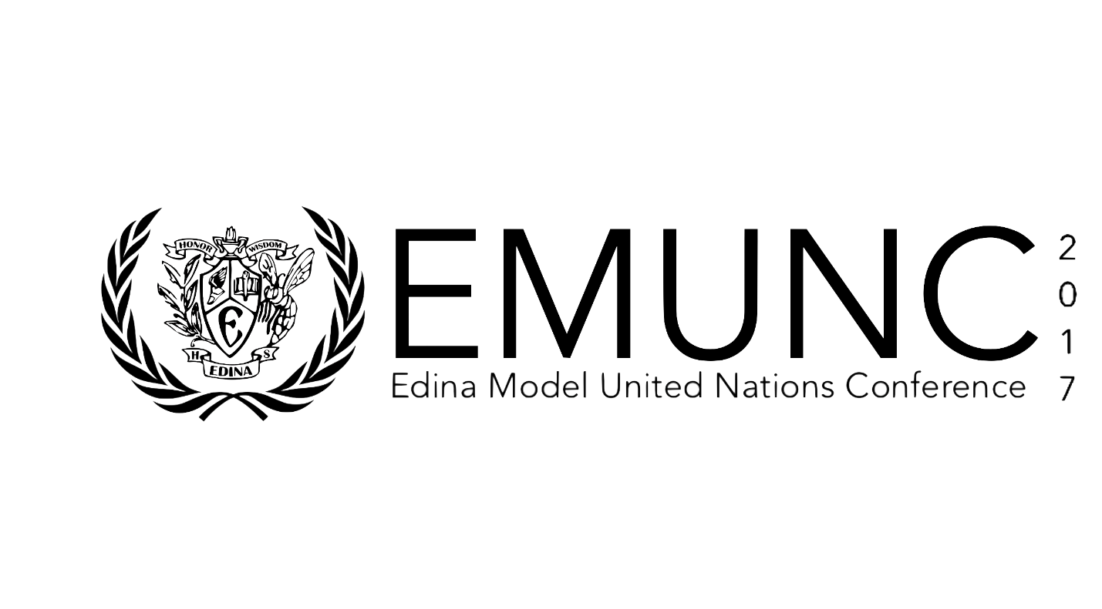

**Transnational Organized Crime**

**United Nations Office on Drugs and Crime**

**January 14th, 2017**

**Edina High School**

**Edina, Minnesota**

**Background Guide**

**Edina Model United Nations Conference 2017**

**United Nations Office on Drugs and Crime (UNODC)**

**Transnational Organized Crime**

**­**

**Description of Committee**

The United Nations Office on Drugs and Crime (UNODC) remains one of the most prominent international groups that focuses on combating drug trafficking and the proliferation of global crime. Created in 1997 as a result of a merger between the United Nations Drug Control and Crime Prevention offices, the UNODC covers a wide spectrum of responsibilities. From fighting against transnational organized crime (TOC) to reducing corruption and strengthening countries’ rule of law, the UNODC uses a mix of on-the-ground analysis and direct cooperation with Member states to accomplish its duties of preventing crime and upholding criminal justice (J5).

**Transnational Organized Crime**

**Introduction**

Transnational organized crime has become one of the most dangerous threats to international stability in recent years. With an estimated market value of US$870B per year (J3), TOC has an unprecedented ability to destabilize nations, hinder political and social development, and cause direct and indirect harms on their populace (J4). With such concrete and immediate dangers posed by TOC, it remains pertinent that every effort be made to eradicate it. However, it is easier said than done. There are roughly four steps the UN should take. First, nations must clearly define transnational organized crime. As of now, there is no standing definition of TOC. Additionally, countries need to identify the causes and facilitators of TOC. Member nations must also understand that there is almost no region that is untouched by TOC. By realizing the extent of TOC, it will make it possible to successfully combat it. Finally, states must change their current approach to TOC. This means nations need to overcome the current challenges that are preventing significant progress against TOC.

The UN has attempted to evaluate what falls under the category of TOC. The only definition that the UN has provided is not one of TOC, but rather of ‘organized crime’. In the UN Convention against Transnational Organized Crime (UNTOC), it is defined as:

1. A group of three or more persons that was not randomly formed;
2. Existing for a period of time;
3. Acting in concert with the aim of committing at least one crime punishable by at least four years’ incarceration;
4. In order to obtain, directly or indirectly, a financial or other material benefit (J1).

The ambiguity of the definition gives the UN the flexibility to administer to almost all types of TOC. This includes more traditional forms of crime like money laundering, but also covers activities like cybercrime which were only made possible by recent technological advancements. However, the problem with this definition is that it fails to truly define what TOC is. As a result, the international community lacks a working understanding of TOC, which inevitably hinders the process of combatting it. In order to create a solid definition, delegates must bridge cultural and political divides to agree upon what TOC actually entails.

Another important aspect of TOC is that it involves many different actors. There are so many types of TOC that eliminating them all would be nearly impossible. Instead, delegates should focus on the main types of TOC. According to UN estimates in 2011, the five highest-grossing types of TOC were: drug trafficking (US$320 B/year), human trafficking ($32 B/year), migrant smuggling ( > US$6.6 B/year), the trafficking illegal firearms (US$170-320 M/year), and the smuggling of natural resources ( > US$3.5 B/year) (J12). However, this is a relatively small list when considering that TOC also covers the sale of fraudulent medicines, cybercrime, and more. This list can seem overwhelming, but by focusing one a few key similarities between the different types of TOC, nations can work towards a practical and achievable solution. First, the root causes of different TOC groups are almost always the same: socioeconomic inequality, a lack of opportunity, and the desire for illicit goods. (J11) While these factors themselves are not new, without them, TOC would not exist. However, what makes TOC transnational and makes it so difficult to fight involves more complex causes. The main catalyst of transnational organized crime lies in the unfettered growth of globalization. The combination of porous borders, unregulated money flows and other factors allowed TOC groups to spread. The creation of new technologies gave TOC groups a new field to expand into. The era of decolonization created a series of nation states that were institutionally weak and unable to defend themselves from the onslaught of TOC groups in the later 1900’s. The collapse of the Soviet Union also created a slew of vulnerable states that also fell prey to TOC in recent years (J13). However, it is important to note that these events are not inherently problematic. Rather, what is an issue is the deregulated condition of the world economy and the largely undisciplined spread of new technologies. When delegates are surveying these causes and determining which ones to address, it is important to narrow the focus of the solution. It may be best to focus on containing TOC rather than completely eradicating its source. Remember, while the root causes of TOC have lasted for centuries, its enabling factors of have only risen in recent years and may be easier to contain.

Delegates must also understand that all regions are affected by TOC. While developed countries are generally more vulnerable to TOC, both developed and developing nations face serious security risks. One example of this is Italy. While the Mediterranean nation is unique in its history of organized crime, the impacts on the state are similar to almost any other country with TOC. Italy’s criminal networks have stunted investor interest, economic growth, and the proper growth of its democratic institutions. Another major blight caused by TOC is corruption. As a result of illicit groups using ill-gotten money for bribery and election-fixing, Italy’s politics have been drowned in corruption. In fact, Italy’s political state is so bogged down by inefficiencies and corruption that less than 30% of Italians trust their government (J6). Furthermore, Italy’s mafias have penetrated into nearby and overseas countries like France and the United States (J7). The case of Italy is not unique: in fact, many Central American countries are even worse off. Central American criminal groups take advantage of globalization, poor rule of law in their home nations, and threaten the well-being of the states and their citizens. In fact, the situation has grown so severe that, according to the Council on Foreign Relations, “Drug cartels have destabilized the Western Hemisphere, leading to the deaths of at least fifty thousand people in Mexico alone in the past six years” (J4).

Thirdly, the UN needs to play a larger role in coordinating efforts between countries. There still remains no precedent of how countries can work together to solve the multifaceted threat of TOC. Judicial and law enforcement cooperation is essential for the prosecution and elimination of TOC. The sharing of intelligence and information is an especially sensitive subject for nations as well. The UN must step in and mediate when situations go awry, whether through neutral task forces or other international peacemaking bodies.

Finally, the UN should encourage nations to look at both supply-side tactics and market-side strategies. Supply-side tactics tend to focus on stamping out the perpetrators of the crime (ex: drug traffickers). Market-focused strategies usually involve community-based actions that decrease the demands for illicit products like illegal drugs, etc. With the combination of all of these possible steps, it is likely that the UN will be able to establish a framework for reducing and containing TOC.

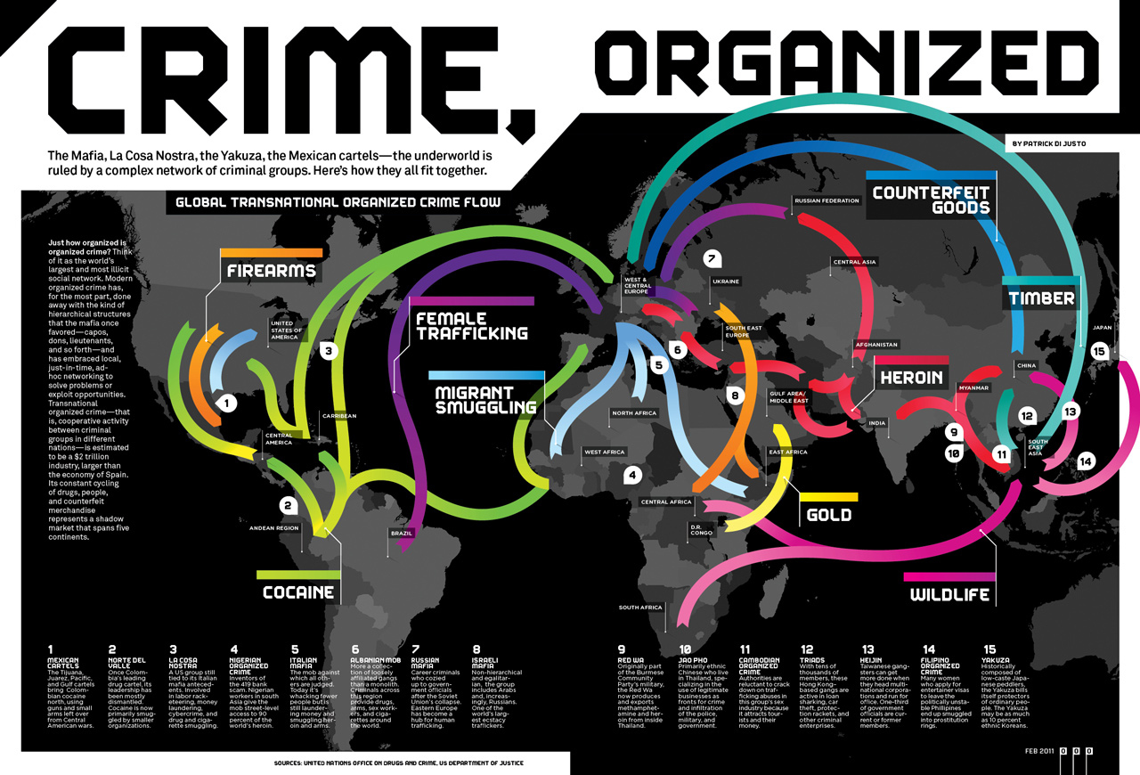Transnational organized crime has only begun to explode: action must be taken, and it must be taken now. The most effective solutions will address the challenges nations face when trying to defeat TOC. The main issue that needs to be addressed is strengthening the weak and outdated infrastructure currently used to combat TOC (J4). Individually, states often rely on crime prevention agencies that operate within their own borders. Their institutions are ill-equipped to deal with the less-hierarchical and transnational nature of TOC. There are also many issues on the international level. The main legal document against TOC, the United Nations Convention against Transnational Organized Crime (UNTOC), does not adequately cover the less-hierarchical and more fluid structures of organized crime. Secondly, the UNTOC does not account for the inability and unwillingness of compromised countries to fulfill their duties. These are nations who profit from selling illegal or counterfeit goods and those that have been completely crippled by TOC. By setting up a framework of political pressure, the UNODC can push the states that benefit from TOC to take measures to contain it. The UNODC can aid nations that have been weakened by TOC by offering technical assistance and developing stronger legal frameworks (J4). (Image M24)

**Background**

*Types of crime*

TOC encompasses several different aspects that delegates must consider. The UNODC states that “transnational organized crime manifests in many forms, including as trafficking in drugs, firearms and even persons” (Ka4). It is imperative for delegations to contemplate the security measures, cybercrime, human rights offenses, fraudulent money, etc. that are encompassed in this diverse, expanding issue. One large challenge with combatting transnational crime is, by definition, TOC crosses borders (Ka6). There is no international precedent on diverse issues that expand from environmental crime to drug trafficking. It is the job of each nation to recognize the root causes of crime within its own borders before trying to minimize the effects of crime in its region.

*Economic impact of crime*

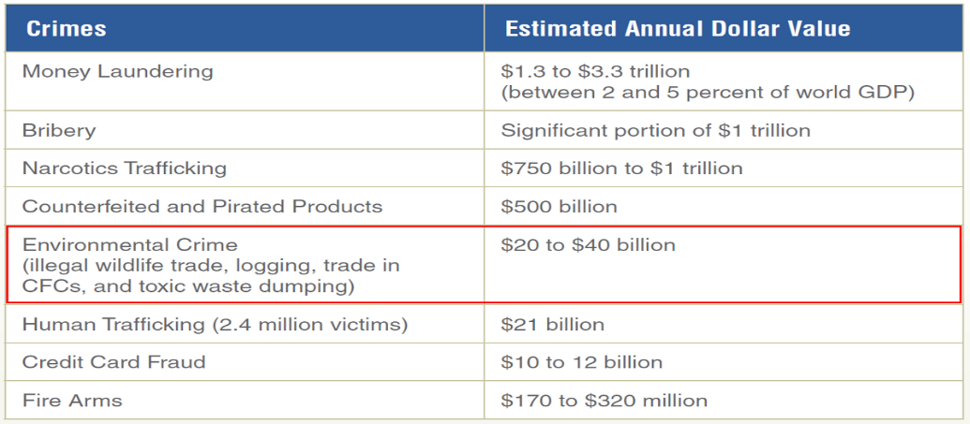Once a state is polluted with crime, it becomes unlikely for a country to receive high levels of foreign investment. (Image M25). Crime and corruption normally scare away investors because there is little promise of transparent returns when money laundering and corruption are prevalent. The General Assembly of the United Nations notes, “Both foreign and domestic investors see crime as a sign of social instability, and crime drives up the cost of doing business” (Ka8). Crime may hurt a state’s economy if they are dependent on importing goods from other countries. Beyond foreign investment, tourism typically loses money when government cannot control illegal activities within its borders (Ka8). When a nation has little foreign investment and tourism, the economy becomes more unstable. As a result of this, citizens lose confidence in their government when the economy is not doing well. Moreover, it becomes difficult to track a nation’s true economic value with high transnational organized crime rates. Money laundering is defined as “the process by which a person conceals or disguises the identity or the origin of illegally obtained proceeds so that they appear to have originated from legitimate sources” (Ka12). Money flow often gets miscalculated by illicit activities and the illegal transport of currency across borders. It’s been internationally noted, at a ten-year review of the Palermo Convention, that anti–money laundering tools have been ineffective. The UNODC reports that [less than 1 percent](http://www.unodc.org/documents/data-and-analysis/Studies/Illicit_financial_flows_2011_web.pdf) of illicit financial flows around the world are seized and frozen (Ka6). The root issue of crime cannot be stopped unless the international community knows how much money is being illegally transported, something that the UNODC doesn’t currently have accurate information on. Another impact of crime is that security and policing measures get an increase in public spending, which takes away from other sectors of a state’s economy. Nations should attempt to cut off funding of terrorist and criminal networks because of the repercussions it places on stable economies across every region.

*Social impact of crime*

Economic disadvantages such as income inequality fester transnational organized crime, impacting how a state functions. World Bank data, for instance, shows that several of the main drug producing or trafficking countries are characterized by highly uneven levels of income distribution (Ka7). When citizens feel neglected in society because of their income level, they often turn to participate in illicit activities for a source of money. Antonio Maria Costa, Executive Director of the United Nations Office on Drugs and Crime (UNODC) stated that “Crime was both the cause and consequence of poverty” (Ka14) Those in poverty not only look to crime for the economic aspect, but distrust their public officials when there is a high unemployment rate, as the government is not helping its citizens. TOC further causes poverty as it leads to violent lifestyles in militias, terrorist groups, etc. and undermines stable police and law enforcement services. Another impact is that criminal activity can lead to health risks, for bystanders and participants. The UN describes that deaths occur as a cause of TOC from “drug-related health problems and violence, firearm deaths and the unscrupulous methods and motives of human traffickers and migrant smugglers are all part of this. Each year millions of victims are affected as a result of the activities of organized crime groups” (Ka11). TOC fosters hazardous, life-threatening conditions for poor and developed nations, which violates human rights such as the right to life, liberty, and the pursuit of happiness. In addition to violence, governments are forced to respond to various medical emergencies which drives up the cost of dealing with crime to a new, overbearing amount. Many developing nations lack the resources to enforce rule of law to take out such criminal groups and consequently, must allocate money to take care of its wounded civilians. Transnational organized crime undermines basic human rights to live in a safe community and dampers mobility, as it umbrellas many devastating worldwide problems.

*Political impact of crime*

When organized crime festers in a state, it challenges the viability of government to protect its citizens and guarantee rule of law. Often, criminal organizations attack the stability of governmental institutions by bribing elected officials. Such corruption often disrupts political decisions in areas such as national budget. Spending gets diverted from services in education, health, and development, which are key to diminish poverty, to transnational crime networks. Cutting social services hurts the poor disproportionately and violates the human right to social assistance. To challenge unfair, corrupt spending, the United Nations Convention Against Corruption crafted a recommendation for “Member States to return assets obtained through corruption to the country from which they were stolen” (Ka5). This new initiative aims to control money that states earn from illicit activities. It not only discourages crime from increasing, but limits the undue influence that criminals have on a state’s spending.

TOC has an indirect impact that “displaces state authority, by filling the governance niches neglected by the official structures and by co-opting whatever vestigial state agents remain. In other words, organized crime groups gradually undermine the authority and the health of the official government” (Ka9). Many crime networks infiltrate the government and cut the budget of police and law enforcement to heighten their success. The UN notes that “effective criminal justice systems and respect for the rule of law are crucial for achieving sustainable development” (Ka10). Many states lack strong justice systems and networks of criminals are let off without punishment for their crime. The international community must hold each state accountable to prosecute and hold criminals accountable with comprehensive legal structures, otherwise, organized groups of criminals relocate from developed nations to developing nations in hopes of staying in business. One of the main issues that political leaders overlook is that organized crime is seen only as a national law enforcement problem, instead of regions working together to target the source (Ka13) Criminals participate in crime across borders because money, drugs, humans, and other things become difficult to track without one single country of origin.

**Challenges in Combating TOC**

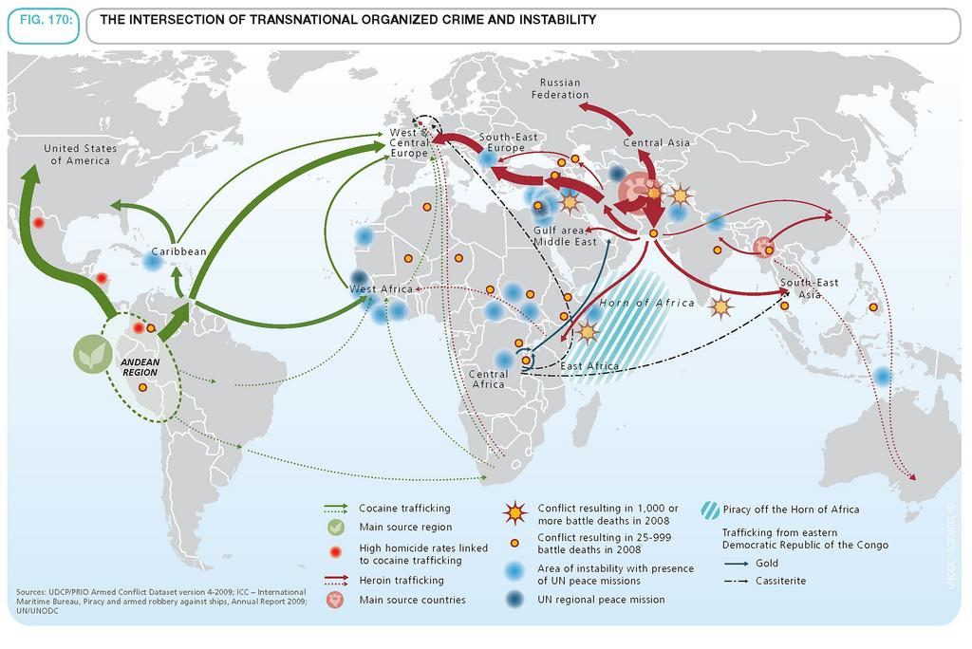There are several aspects of Transnational Organized Crime (TOC) that make it difficult to combat. With the rise of globalization and technological advancements, the nature of organized crime has continued to evolve (M8). Organized crime groups take advantage of globalization and free trade across borders to expand their networks (M4). As a result of these fluid networks, crime groups are able to facilitate communication between each other and assert more power. Growth in world trade and communication has led to money laundering, just one among many of the crimes that groups commit. Due to groups’ fluid networks, it is extremely difficult for countries to identify the source and ownership of the large sums of money in circulation. The task is made more difficult due to the rapid rate at which criminal groups transfer sums of money. Many groups utilize advanced technologies as mediums of their exchanges. This reduces their need for paperwork, so it virtually eliminates the amount of incriminating evidence law enforcement officials can use against these groups (M9). If any one country tries to combat money laundering by controlling the flow of capital, the result would be contrary to the original intent of keeping the banking sector liquid, powerful, and intact (M5). Herein lies another challenge in combating TOC: no one country can effectively combat TOC on its own (M1). (Image M26)

Combating TOC requires mobilization and collaboration: Yuriy A. Voronin, Professor of Criminal Law stated, “Transnational criminal rings are becoming more and more powerful and universal, and their mobility is growing. The means and resources of any state are not enough to seriously harm them” (M7). International cooperation is necessary for effectively combating TOC, but it is difficult to mobilize nations because each nation's lawmakers and policymakers all have different fundamental principles of thinking defining the freedom within which they can operate. Not only do countries have different definitions for what types of crime exist (M9), but they are also reluctant to “conform legislative instruments and practices to the needs of international cooperation and develop functional frameworks for international cooperation and appropriate mechanisms” (M5). Another reason why it is so difficult for nations to collaborate is because often times, crime groups erode citizens’ trust in the government after “impeding the quest of countries to growth, stability, and steady progress towards democracy” (M4). Mobilization often involves nations pooling in their resources to synergize efforts against a problem. In combating TOC, however, pooling resources is difficult, especially for developing countries. Crime groups target developing nations and regions where there is economic and political unrest due to their vulnerabilities. Crime groups base many of their operations out of these regions because there are decreased risks involved and they have the ability to eliminate competition through intimidation and violence (M5). These are just a few of the challenges that arise when countries attempt to combat TOC. Combating TOC is a difficult task, but by having a firm understanding of what some of those challenges are, it will be possible for delegates to design more creative and innovative plans for solving this complex issue.

**International Action**

*Past actions of the UN*

The United Nations has been instrumental in combating Transnational Organized Crime (TOC) in recent years. On November 15th, 2000, the UN General Assembly adopted the standards set out by the UN Convention on Transnational Organized Crime (UNTOC) (Kh1). The three main parts of the UNTOC (also called the Palermo Convention) are: the protocol to stop human trafficking (especially in women and children), the protocol to end smuggling of migrants, and the protocol to stop arms trafficking. All three of these protocols encourage countries to work together in order to stop the flow of illicit goods. If countries can prevent criminal organizations from accessing foreign markets, it will be much harder for them to expand. As of August 21, 2013 the UNTOC had 147 signatories (Kh3). By signing this convention, states indicate that they recognize the seriousness of TOC. States that ratify this accord commit themselves to taking a series of measures to combat transnational organized crime. These may include: the creation of domestic criminal offences, the adoption of new procedures for extradition, law enforcement cooperation between states, and upgrading domestic enforcement authorities (Kh2). Implementing these measures will allow states to fight TOC both domestically and internationally. The UNTOC has been able to provide a comprehensive framework countries can use to target specific areas of TOC. Despite this, it has not been able to adapt to new methods of crime. For example, the Palermo convention does not address cyber-based crime and is thus extremely ineffective at fighting it (Kh4).

*Other international peacemaking bodies*

Several other international organizations are working to combat TOC. The Association of Southeast Asian Nations (ASEAN) has been working to eradicate TOC in member countries since the early 1970s. Initially, ASEAN was primarily focused on decreasing drug trafficking. In order to do this, the organization implemented programs that targeted the demand of narcotics and mechanisms that made information sharing between member states easier. At the First Informal Summit in November 1996, ASEAN leaders encouraged member countries to increase regional cooperation on all criminal matters. At the Second Informal Summit in December 1997 they officially resolved to work to eradicate drug trafficking, human trafficking, and other types of TOC (Kh5).

Another international organization that is taking measures to combat TOC is the Organization of American States (OAS). In October 2006, the OAS implemented the Hemispheric Plan of Action against Transnational Organized Crime. The general objectives of this plan are to: combat transnational organized crime using the Palermo Convention as a framework, enhance cooperation between member states in areas related to TOC, increase cooperation between the OAS and other international organizations dedicated to fighting TOC, and strengthen national capabilities to deal with TOC (Kh6).

Finally, the North Atlantic Treaty Organization (NATO) is another organization that is fighting against TOC. In 2004, NATO adopted a zero-tolerance policy on human trafficking. Since then NATO has worked closely with the UNODC and law enforcement agencies to ensure member states know how to effectively fight this problem (Kh7). NATO has also agreed to help several countries improve their counter-narcotics measures. In Afghanistan, joint Afghan-NATO operations have destroyed 459 tons of poppy seeds, 51 tons of opium, and 41 illicit laboratories (Kh8).

*Actions to be continued*

Although progress is being made in reducing TOC, there is still much to be done. First, it is imperative that countries work to educate their citizens about the effects of TOC. If people know about TOC, they are less likely to unknowingly support it through the purchases they make. Many corporations use unethical and illegal means in their supply chains and it is important consumers are aware of this (Kh9). Furthermore, current strategies for combating TOC focus too little on fighting corruption and the relationship between TOC and illegitimate political power. If the international community wants to truly end TOC, it needs to reduce existing corruption (Kh10). The international community also needs to do a better job of adapting to new types of crime. Cybercrime is a new emerging form of TOC. The crime takes place in the borderless realm of cyberspace and thus has consequences that affect the entire world (Kh11). The overall monetary impact of transnational cybercrime is estimated to be in the billions of dollars (Kh12). Despite this, very few international organizations recognize the threat transnational cybercrime poses and the Palermo convention does not address it. Finally, it is vital that international organizations continue to provide humanitarian assistance to underprivileged countries. There is a significant relationship between poverty and crime. People in developing countries frequently join criminal organizations because it’s the only way to feed their families. If international organizations can ease citizens of this burden by providing humanitarian assistance and new job opportunities, far fewer people will join criminal groups in the first place (Kh12).

**Case Studies**

*West Africa*

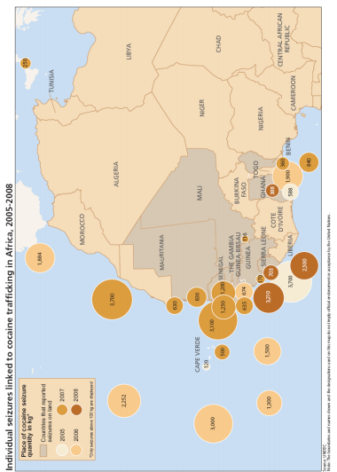As a result of globalization, West Africa has had an extensive history of drug trafficking and exploitation of natural resources that has expanded into other avenues of transnational organized crime. The White House notes that “TOC exacerbates corruption and undermines the rule of law, democratic processes, and transparent business practices in several African states that already suffer from weak institutions” (Ka15). Many West African nations now rely on international legal frameworks for governance because of weak individual political leaders and systems, making them vulnerable to criminal networks. All but three of the sixteen West African nations are labeled as the “least-developed countries” by the United Nations (Ka13). This overwhelming instability allows criminals to take advantage of political leaders without resistance which is why drug trafficking has a rampant history in the region. In Guinea-Bissau, for example, the UNODC has declared that “several journalists and activists have had to flee the country or go into hiding after they received death threats for reporting on military involvement in drug trafficking” (Ka13). High levels of corruption skew rule of law in these countries, leaving each state vulnerable to TOC. Because of the region’s instability, natural resources serve as a prime opportunity for drug exports. West Africa is a key cocaine distributor to European nations and transit point for drug cartels from Latin America. (Image Ka16)

One large issue that makes transnational organized crime an international crisis is keeping track of who is truly involved. The UNODC states “once on African soil, it is unclear what share remains in control of South American organized crime groups and what share is transferred to West African or European groups” (Ka2). The solution to curtail drug trafficking requires law enforcement to communicate across the globe, strengthen international frameworks, and prevent the root causes of crime. However, many West African nations suffer from weak governance which limits any progress on curtailing TOC. One example of this is Guinea-Bissau in which high ranking officials, the government and the military are complicit in drug trafficking, allowing questionable judicial and legal decisions in regards to cocaine (Ka2). Money fuels this corruption, and therefore, the international community can control the power of drug networks in West Africa. As a well-known supplier of natural resources to drug traffickers, West African nations suffer financially without foreign investment. The African Union Commission says “Less than 1% of global Foreign Direct Investment (FDI) comes to Africa” (Ka1). Financial assets are crucial to a government’s ability to govern. West Africa has been forced to address its instability and impoverishment because of low FDI, as international support is crucial for development. Some nations have a greater value in drug trafficking than their national income which is unsustainable for future generations who have been stripped of social services such as medicine, health insurance, etc (Ka16). Socioeconomic development is key to crafting a long-term solution for West African states. Many governments are undermined by complex transnational crime networks and lack control over political and economic decisions. Although sorting out West Africa’s drug problems won’t solve all problems, it will help reduce economic hardship, mobilize younger generations out of instability, and generate transparent data to tackle transnational organized crime within the region.

*East Africa*

Despite the pervasiveness of TOC in East Africa, this region often garners less concern than the visibly-embattled West Africa. However, that does not mean that the problems are any less extensive. In fact, what makes the situation in East Africa potentially more dangerous is that TOC is hidden beneath a mirage of government competence. The very institutions that are supposed to stop TOC are all too often hijacked by the criminals themselves. One example of this is Kenya. In this East African country, drug trafficking remains one of the largest threats to national sovereignty. Not only is there an immediate security threat, but the groups have subverted the government to an indescribable level. Through bribery and money laundering, drug traffickers caused a large part of Kenya’s huge problem with corruption and government incompetence. In 2011, approximately 90% of Kenyans view their country as being ‘between corrupt and extremely corrupt,’ and only about “7% [of Kenyans] expressed trust in Parliament, 8% in the judiciary, and 8% in the Kenya Police Service” (J10). Not only are drug traffickers removing Kenya’s ability to administer to its people, but they are also threatening one of the foundations of the government’s legitimacy. With such low approval ratings, it would be no surprise to many onlookers if political turmoil ensued, further weakening the state. It is important to note that Kenya is not the only E. African country struggling with drug trafficking. In fact, the entire region of East Africa is both a market and transit hub for illicit drugs, especially in heroin. The UNODC estimates that E. Africa consumes 2.5M tons of heroin alone per year, which nets its traffickers about US$160M (J8). Not only that, but the Institute for Security Studies points out that the most powerful drug cartels in S. America are using E. and W. Africa as major shipping points for illegal drugs. If African governments can successfully crack down on the flow of illegal drugs, they could close down a major highway for drug trafficking. Migrant trafficking also poses a huge threat to the E. African region. Chronic political instability and lack of opportunity created vast streams of economic migrants. Unfortunately, this also means that that human traffickers flock to this area in droves. While most of the migrants come from only two countries, Somalia and Eritrea, the number of migrants is staggering (J8). About 100,000 people attempt to escape from E. Africa in one year alone. Unfortunately, many are led astray by their smugglers and are subject to horrible abuse, . In 2012 alone, human traffickers earned about US$15 M in the East African region. However, there is an even more lucrative illicit activity in this area: piracy. In the year 2011 alone, Somali pirates brought in an estimated US$150M in 2011. For comparison, that is about 15% of Somalia’s GDP as a whole. However, piracy is one of the forms of TOC that is successfully being reduced. Due to the important geographical location of Somalia’s coast, international efforts against piracy have been intense and effective. According to UNODC estimates, April of 2009 saw 16 hijacked ships. Two years later, pirates averaged less than one ship per month.

Now that East Africa’s deep problems with transnational organized crime are revealed, it is time for the next step: how can these issues be resolved? The most direct answer seems to be to address the enabling factors. In response to the flow of illegal drugs, efforts must be made to improve the rule of law. There needs to be improved coordination of law enforcement, and anti-corruption measures must be taken as well. The best way to staunch human trafficking in E. Africa also needs to include the solidifying of border control. Nations must focus on the areas where the smuggling is most concentrated: the ports in Djibouti and Somalia. Finally, while piracy has been on a steady decline, there are still steps that should be taken. The international community should continue its efforts against maritime crime, but the causes of piracy (poverty, lack of opportunity, etc.) must be reduced. Combined anti-corruption measures and criminal justice reforms will make piracy much less lucrative. Therefore, it is hoped that the threat that it poses to nations’ sovereignty will be significantly hampered in the long run. None of the aforementioned solutions will be easy to implement, but all will aid in the long-term fight against TOC.

*East Asia and Pacific*

Transnational organized crime represents an enormous threat to Eastern Asia and the Pacific. The first major type of crime prevalent in this region is the smuggling of migrants. Myanmar in particular has contributed to the large number of illegal migrants. Economic sanctions against the government, conflict, and economic stagnation have all encouraged large numbers of migrants to leave the country using illegal means (Kh15). Smugglers have played an integral role in the mass migrant movement. They allow migrants to expedite the process of immigration by helping them evade border control. This makes using smugglers an attractive option for migrants eager to leave their home country quickly (Kh15). In the early 2000s there were approximately 3.8 million illegal migrants in East Asian countries (Kh16). This is a major problem because smuggled migrants frequently place their lives in the hands of criminal organizations and are vulnerable to exploitation. Migrants don’t own legal forms of ID and have no choice but to work for the exploitative wages smugglers offer them. Research on Cambodian migrants found that in cases involving smugglers, the average promised salary was around $120/month whereas they actually ended up getting paid around $15/month (Kh15).

Another type of TOC affecting East Asia and the Pacific is sex trafficking. Despite prostitution being illegal in Thailand, a survey in 2009 found that there were approximately 73,917 sex workers and around 16,000 commercial sex establishments (Kh15). A large number of these victims were trafficked from countries like Cambodia, Myanmar, and Vietnam (Kh15). One group of people that is susceptible to being trafficked is smuggled migrants. Many traffickers control migrants through debt bondage gathered from the cost of smuggling them. Victims are often forced into sex trafficking in order to pay off their debts (Kh15).

A third type of TOC affecting East Asia and the Pacific is drug trafficking. The region is mostly comprised of developing states that are prone to widespread corruption (Kh17). Drug traffickers have exploited these conditions to reap financial rewards at the expense of the people living there. The notorious Golden Triangle region of Burma, Laos, and Thailand accounts for about 65% of all opium produced illegally and supports a heroin market estimated to be worth around $160 billion annually (Kh17). The impact of this drug trade is extensive. One senator of the Philippines noted that the enormous amount of drug money flowing into his country was “corrupting and co-opting elements in immigration, customs, the police, and the military” (Kh17). It is evident that TOC poses a serious threat to countries in East Asia and the Pacific. The UNODC has noted that any successful plan to combat TOC in this region must include both rule of law (ex. governance, prosecuting criminals, etc.) and health development (for example drug demand reduction, sustainable livelihood opportunities, etc.).

*Central Asia*

Transnational organized crime is a major problem in Central Asia. Drug trafficking is currently the most serious issue facing the region (Kh13). In the Indian Ocean, the Combined Maritime Forces (CMF) has recently reported an increased quantity of seized opiates coming from the Central Asian region (Kh14). Almost all of the opiates originate from Afghanistan. According to the 2015 UNODC World Drug Report, Afghanistan accounted for 77% of global heroin production and 85% of global opium production (Kh14). Considering Afghanistan’s current political landscape it is unsurprising that it is a major producer of opium. The government is unable to control large parts of the country due to the prevalence of Anti-Government Elements in many southern provinces, which is also where the majority of opium is produced (Kh14). This lack of governmental control combined with a shortage of legitimate employment opportunities has created an environment conducive to the production of drugs (Kh14).

With Tajikistan, Turkmenistan, and Uzbekistan sharing a border with Afghanistan, the Central Asian region overall has become an important transit zone for illegitimate drugs (Kh13). To understand the prevalence of drugs in the Central Asia, it is important to look back to the era of the Soviet Union. The states of Central Asia were formerly dominated by Moscow and have inherited skewed trade patterns, skewed patterns of industrial production, corruption, and a series of obstacles that have inhibited democratization (Kh13). Today, Central Asian governments suffer from a number of functional gaps. These can be described as the failure of a country to fulfil basic things expected by the citizenry (ex. adequate employment opportunities). Criminal organizations are often able to exploit these gaps for their own benefit (Kh13).

As a result, the Central Asian region has become a major center of production for illicit drugs. Organized crime has had a grave effect on Central Asian states by hampering potential investment opportunities and undermining state institutions (Kh13). Promoting international cooperation, strengthening political will, and reforming state institutions will all help bring political stability to the region and help end the proliferation of organized crime (Kh13).

*Southeastern Europe*

Transnational organized crime exists in many forms and structures in Southeast (SE) Europe. There are 3 primary motives for TOC groups to exist, including economic (material gains through drug smuggling, burglary, etc.), social (providing forums for exchange of information and providing fluidity to groups), and quasi-governmental (supporting illegal economic activities) gains. In terms of structure, there are independent actors, networks, criminal organizations, and mafias. Each group has a different structure within which they operate. All types of groups exist in SE Europe (M16). The complex nature of these groups make it difficult for security and justice officials to disentangle their structures, organizations, and motives. Furthermore, there are several cities (ex: Amsterdam) within SE Europe that have been identified as important meeting places for TOC groups. Groups with absolutely no ties or relations can connect at various meeting places ranging from prisons to parties to international tax conferences where they can attend under the guise of financial professionals so they can conspire in large-scale tax fraud (M14).

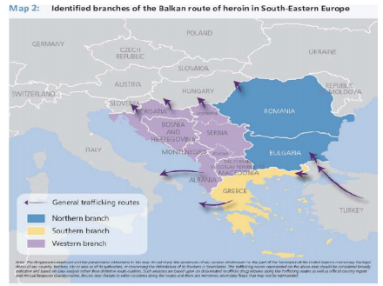TOC groups engage in all types of crime including corruption (M18), human trafficking for both sexual and labor exploitation (M14), illegal migration (M19), arms smuggling (M14), illegal trade in human organs (M14) and money laundering (M20). SE Europe also serves as an “important destination for other illegal goods such as protected cultural artifacts, protected wildlife, counterfeit brand products (ex: medicine, software, cigarettes)” (M14) as well as stolen motor vehicles and illegal waste (M16). Though SE Europe is home to many different crimes, the biggest of them all is drug trafficking. The “Balkan route” is a heroin supply route between Afghanistan and Europe (M12) and according to the UNODC, an estimated 60-65 tons of Afghan heroin flows through SE Europe annually, much of it passing through this route (M12). This region has also experienced an expansion in the trafficking of Albanian cannabis and South American cocaine. Even though seizure volumes in this region have declined recently, shipments are continuing to be made. Crime groups prefer to transport substances using road vehicles, and their shipments are so well organized and planned, that they continue to remain undetected. (Image M16)

Many SE European countries are part of the European Union, so there are lessened border controls for freight goods, which allows for more trafficking to occur. Large heroin shipments are broken up within SE Europe among countries like Albania, Kosovo, and the Former Yugoslav Republic of Macedonia (M12), further hiding the activities of TOC groups from security and law officials. “Groups are also using more effective forms of communication and more sophisticated *modus operandi*, and are expanding into new markets as well as building networks at all stages of the supply chain” (M12). As a result, there is limited data and inconsistent information on the illegal drugs that are being transported, making it difficult for law enforcement bodies to legitimately prosecute crime groups.

In response to the growing threat that drug trafficking poses to the entire SE European region, the Southeast European Law Enforcement Center (SELEC) was formed to “advocate shared responsibility on the part of all countries affected by Afghan opiates” (M12). Other international cooperative measures include the Paris Pact Initiative, a group of more than 70 countries and international organizations collaborating to respond to the threat of Afghan opiates and to strategically analyze the trafficking occurring along the Balkan route (M13). In 2011, the Paris Pact countries and international bodies conducted “Operation Soya,” a series of 21 joint investigations to seize large amounts of illegal substances along the Balkan Route. They later expanded the number of investigations to 27 in 2012 (M13). The SE Europe Regional Program of the UNODC lays out goals towards preventing all kinds of crimes pervasive in SE Europe, including “strengthening border control, increasing access to reliable data, inter- and intra-regional information/intelligence exchange to improve profiling, increasing joint operations and anti-money laundering cooperation, and preventing trafficking in persons and smuggling of migrants” (M15).

The problems affecting SE Europe are not strictly limited to that region; they affect the entire world and only through “raised awareness, increased use and development of cooperation mechanisms and forensic capacity building,” (M12) can countries take one step closer in effectively combating TOC.

*Central America*

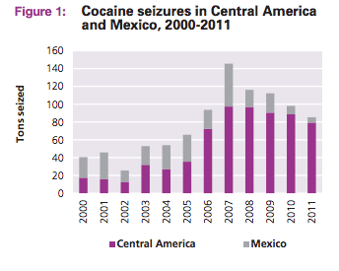Organized crime is a paramount issue that affects all Central American countries. “The paramount crime issue [in Central American countries] is cocaine trafficking, the groups empowered by it, and the violence associated with this flow” (M22). Since 2006, the region has experienced an increase in cocaine trafficking: “cocaine trafficking is currently the most lucrative organized crime activity in Central America” (M21). 2006 was the year that the Mexican government implemented a new national security strategy, which made it more difficult and dangerous for traffickers to ship cocaine directly to Mexico. As a result, the flow of cocaine increased through different routes within Central America. Because the new paths for cocaine smuggling ran through territories controlled by various organized crime groups, the balance of power was disturbed. These groups were already involved in cross-border trafficking, but because the volume of cocaine greatly increased in their territories, competition for territorial control ensued: “these groups, not the flow of cocaine, are the core cause of violence in this region” (M21). The “key driver of violence is not cocaine, but change: change in the negotiated power relations between and within groups, and with the state” (M21). (Image M16)

Two kinds of crime groups exist in this region: territorial and trafficking (*transportista)* groups. Territorial groups focus on maintaining control over geographic area and employ some violence. Organized crime families, such as the Guatemalan crime families (M21), fall under this category because they govern remote areas of countries, manipulate local politics, and engage in a wide range of organized crime activities (M22). Regarding the nature of the territorial crime groups, they “act like a state within the state, and can easily move into other forms of criminality should their current portfolio of activities prove unprofitable” (M21). Transportista groups, unlike territorial groups, prefer to “fly under the radar” (M21). Crime and particularly criminal violence, in addition to cocaine trafficking, is “regarded as one of the most important issues facing Central American countries today” (M21).

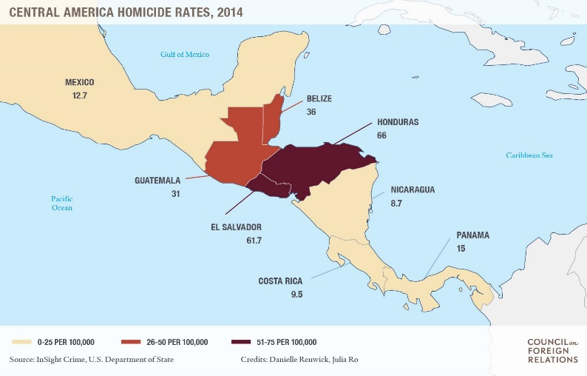There are often correlations between trafficking in certain countries and murder rates in those countries. In Guatemala and Honduras, for example, there are correlations between trafficking areas and murder rates. Crime groups in these countries are involved in extortion and migrant smuggling. In El Salvador, however, though country has the highest recorded number of sustained murder rates in the Central American region, those rates are independent of cocaine flow (M22). El Salvador, Guatemala, and Honduras, are all countries part of the “Northern Triangle,” a region within Central America known for its “legacy of violence and fragile institutions” (M23). Besides cocaine smuggling and violence in the Central American region, migrant smuggling and firearms/military weapons smuggling are also huge problems. Territorial groups prey on vulnerable migrants sometimes for ransom, but often times for the purpose of sexual exploitation, especially in countries like Guatemala and Mexico (M22). (Image M23)

In an attempt to combat crime, several anti-crime efforts within Central America have been launched. However, these efforts have largely been unsuccessful due to the somewhat repressive and militarized approach as opposed to more peaceful and diplomatic intervention. These efforts have been ineffective because they carry the risk of further aggravating violence, and damaging the governance and criminal justice systems of already weakened states. Furthermore, “poor investigation, lack of prosecutorial capacity, and high levels of judicial corruption” on the part of countries attempting to combat crime, have resulted in extremely low conviction rates of crime groups (M21): “As many as 95% of crimes go unpunished in some areas, and the public has little trust in the police and security forces” (M23). In regards to preventing cocaine trafficking specifically, trying to “diminish flows of cocaine can actually exacerbate violent competition, and more direct forms of criminal income acquisition can cause more violence than drug trafficking...for actual progress to be made, the risk of aggravating violence in the short term must be taken into account” (M21). Hence, to effectively combat the problem of transnational organized crime that persists within Central America and around the world, a strategic framework, national crime prevention strategies, and above all, international coordination, are needed.

**Guiding Questions**

1. What recent experience does your country have with transnational organized crime?
2. What types of crime outlined in this guide does your country believe to be the most pressing for the international community at this time? Why?
3. Is your country more interested in combating the causes of transnational organized crime or in containing current threats posed by various crime groups?
4. What first steps would your country take to collaborate and pool resources with other nations affected by transnational organized crime?
5. Which of the economic, political, or social impacts of transnational organized crime is your country most affected by?
6. Apart from cases of tangible terrorism and hate crimes that exist across the world, what are some of the lesser known crimes, if any, that affect your country specifically?

**Works Cited**

(Kh1) "United Nations Office on Drugs and Crime." *India: Significance of the United Nations Convention against Transnational Organized Crime (UNTOC) to Address Human Trafficking*. N.p., n.d. Web. 25 Aug. 2016. <<https://www.unodc.org/southasia/en/frontpage/2011/june/significance-of-the-untoc-to-address-human-trafficking-interview-with-mr-g-k-pillai.html>>.

(Kh2) "United Nations Office on Drugs and Crime." *Convention on Transnational Organized Crime*. N.p., n.d. Web. 25 Aug. 2016. <<https://www.unodc.org/unodc/treaties/CTOC/>>

(Kh3 International Framework To Fight Against Transnational, Organized Crime And Human Trafficking:, and The Un Approac. *The UN ApproachApproaching Universal Ratification* (n.d.): n. pag. Web. <<http://www.undp.org/content/dam/vietnam/docs/Article/UNODC%20presentation%20UNTOC%2029.8.pdf>>.

(Kh4) "2014: A Marker of the Effectiveness UNTOC." *Global Initiative*. N.p., n.d. Web. 25 Aug. 2016. <<http://globalinitiative.net/untoc2014/>>.

(Kh5) Action, Asean Plan Of, To Combat, and Transnational Crime. *ASEAN PLAN OF ACTION TO COMBAT TRANSNATIONAL CRIME A. (a) BACKGROUND The Mandate for ASEAN Cooperation In Combating Transnational Crime* (n.d.): n. pag. Web. <<https://www.mfa.gov.sg/content/dam/mfa/images/om/UN_new_york/AnnexG.pdf>>.

(Kh6) "DPS Transnational Organized Crime Key Documents." *SSM*. N.p., n.d. Web. 25 Aug. 2016. <<http://www.oas.org/dsp/english/cpo_crimen_documentos.asp>>.

(Kh7) "United Nations Office on Drugs and Crime." *UNODC Provides Regular Training at NATO School on Trafficking in Persons and Smuggling of Migrants*. N.p., n.d. Web. 25 Aug. 2016.<<https://www.unodc.org/unodc/en/human-trafficking/2011/unodc-provides-regular-training-at-nato-school-on-trafficking-in-persons-and-smuggling-of-migrants.html>>.

(Kh8) N.p., n.d. Web. <<http://www.un.org/press/en/2009/gashc3948.doc.htm>>.

(Kh9) "Transnational Organized Crime:Let's Put Them out of Business." *Let's Put Organized Crime out of Business. What's Being Done and How You Can Help*. N.p., n.d. Web. 25 Aug. 2016. <<https://www.unodc.org/toc/en/whatsbeingdone.html>>.

(Kh10) "The Global Regime for Transnational Crime." *Council on Foreign Relations*. Council on Foreign Relations, n.d. Web. 25 Aug. 2016. <<http://www.cfr.org/transnational-crime/global-regime-transnational-crime/p28656>>.

(Kh11)"United Nations Office on Drugs and Crime." *Emerging Crimes*. N.p., n.d. Web. 25 Aug. 2016. <<https://www.unodc.org/unodc/organized-crime/emerging-crimes.html>>.

(Kh12) "Poverty and Crime: Breaking a Vicious Cycle of Discrimination." *RSS*. N.p., n.d. Web. 25 Aug. 2016. <<http://www.poverties.org/blog/poverty-and-crime>>.

(Kh13) 200, New York. *AN ASSESSMENT OF TRANSNATIONAL ORGANIZED CRIME IN CENTRAL ASIA* (n.d.): n. pag. Web. <<https://www.unodc.org/documents/organized-crime/Central_Asia_Crime_Assessment.pdf>>.

(Kh14) The Afghan Opiate Trade And Africa - A Baseline Assessment 2016. *The Afghan Opiate Trade and Africa - A Baseline Assessment 2016* (n.d.): n. pag. Web. <<https://www.unodc.org/documents/data-and-analysis/Afghanistan/Afghan_Opiate_trade_Africa_2016_web.pdf>>.

(Kh15) "Transnational Organized Crime in East Asia and the Pacific." (2013): n. pag. Web. <<https://www.unodc.org/documents/data-and-analysis/Studies/TOCTA_EAP_web.pdf>>.

(Kh16) "Migration in the Asia-Pacific Region." *Migrationpolicy.org*. N.p., 10 July 2009. Web. 25 Aug. 2016. <<http://www.migrationpolicy.org/article/migration-asia-pacific-region>>.

(Kh17) Your Use Of The Jstor Archive Indicates Your Acceptance Of Jstor's Terms And Conditions Of Use, Available At. *Http://www.jstor.orgCRIME, DRUGS, TRANSNATIONAL AND SECURITY IN EAST ASIA* (n.d.): n. pag. Web. <<http://n.ereserve.fiu.edu/010034787-1.pdf>>.

(J1) "Organized Crime." United Nations Office on Drugs and Crime. United Nations, n.d. Web. 30 July 2016. <<https://www.unodc.org/unodc/en/organized-crime/index.html>>.

(J2) Picarelli, John T. "The Evolution of Transnational Organized Crime." National Institute of Justice. US Department of Justice, 3 Nov. 2011. Web. 30 July 2016. <http://www.nij.gov/journals/268/pages/transnational-evolution.aspx>.

(J3) "New UNODC Campaign Highlights Transnational Organized Crime as a US$870 Billion a Year Business." United Nations Office on Drugs and Crime. United Nations, 16 July 2012. Web. 1 Aug. 2016. <<https://www.unodc.org/unodc/en/frontpage/2012/July/new-unodc-campaign-highlights-transnational-organized-crime-as-an-us-870-billion-a-year-business.html>>.

(J4) "The Global Regime for Transnational Crime." Council on Foreign Relations. Council on Foreign Relations, 25 June 2013. Web. 2 Aug. 2016. <http%3A%2F%2Fwww.cfr.org%2Ftransnational-crime%2Fglobal-regime-transnational-crime%2Fp28656>.

(J5) "United Nations Office on Drugs and Crime (UNODC)." International Association of Anti-Corruption Authorities. IAACA, 15 Feb. 2012. Web. 2 Aug. 2016. <<http://www.iaaca.org/AntiCorruptionAuthorities/ByInternationalOrganizations/InterGovernmentalOrganization/201202/t20120215_805480.shtml>>.

(J6) "Italy-Corruption." Global Security. Global Security, n.d. Web. 31 Aug. 2016. <<http://www.globalsecurity.org/military/world/europe/it-corruption.htm>>.

(J7) file:///C:/Users/Dehong/Downloads/italian_organised_crime_threat_assessment_0.pdf

(J8) United Nations Office on Drugs and Crime. "Transnational Organized Crime in Eastern Africa: A Threat Assessment." TRANSNATIONAL ORGANIZED CRIME IN EASTERN AFRICA: (n.d.): n. pag. United Nations Office on Drugs and Crime. UN, Sept. 2013. Web. 2 Aug. 2016. <<https://www.unodc.org/documents/data-and-analysis/Studies/TOC_East_Africa_2013.pdf>>.

(J9) “Transnational Organized Crime: A Growing Threat to National and International Security." The White House. The White House, 25 July 2011. Web. 31 Aug. 2016. <<https://www.whitehouse.gov/administration/eop/nsc/transnational-crime/threat>>.

(J10) Gastrow, Peter. "Termites at Work: Transnational Organized Crime and State Erosion in Kenya." (n.d.): n. pag. International Peace Institute. International Peace Institute, Sept. 2011. Web. 30 July 2016. <<https://www.ipinst.org/images/pdfs/ipi_epub-kenya-toc.pdf>>.

(J11) Finckenauer, James O. "Meeting the Challenge of Transnational Crime."National Institute of Justice (2000): n. pag. National Institute of Justice Journal. National Institute of Justice, July 2000. Web. 10 Aug. 2016. <<https://www.ncjrs.gov/pdffiles1/jr000244b.pdf>>.

(J12) "Transnational Organized Crime: The Globalized Illegal Economy."Transnational Organized Crime:Let's Put Them out of Business. United Nations Office on Drugs and Crime, n.d. Web. 01 Sept. 2016. <<https://www.unodc.org/toc/en/crimes/organized-crime.html>>.

(J13) Williams, Phil. "How Globalization Affects Transnational Crime." Interview by Stewart M. Patrick. Council on Foreign Relations. Council on Foreign Relations, 30 May 2012. Web. 9 Aug. 2016. <<http://www.cfr.org/transnational-crime/globalization-affects-transnational-crime/p28403>>.

(Ka1) 2005. Berlin: De Gruyter, 2005. Crime and Development in Africa. UNODC, June 2005. Web. 23 Aug. 2016. <https://www.unodc.org/pdf/African_report.pdf>

(Ka2) Research and Analysis Section and the Regional Office for Western and Central Africa of UNODC. 2007. National Trust, 2007. Cocaine Trafficking in West Africa. UNODC, Dec. 2012. Web. 24 Aug. 2016. <https://www.unodc.org/documents/data-and-analysis/west_africa_cocaine_report_2007-12_en.pdf>.

(Ka3) "Organized Crime and Corruption." *Organized Crime and Corruption*. UNICRI, n.d. Web. 24 Aug. 2016. <http://www.unicri.it/topics/organized_crime_corruption/>.

(Ka4) "United Nations Office on Drugs and Crime." *Organized Crime*. UNODC, n.d. Web. 24 Aug. 2016. <https://www.unodc.org/unodc/en/organized-crime/index.html>.

(Ka5) "UNITED NATIONS (U.N.): CONVENTION AGAINST CORRUPTION."*International Legal Materials* 43.1 (2004): 37-73. *UNITED NATIONS Office On Drugs and Crime*. UNODC, 2004. Web. 24 Aug. 2016. <https://www.unodc.org/documents/treaties/UNCAC/Publications/Convention/08-50026_E.pdf>.

(Ka6) "The Global Regime for Transnational Crime." *Council on Foreign Relations*. CFR, 25 June 2015. Web. 24 Aug. 2016. <http://www.cfr.org/transnational-crime/global-regime-transnational-crime/p28656>.

(Ka7) Pietschmann, Thomas, and John R. Walker. Estimating Illicit Financial Flows Resulting from Drug Trafficking and Other Transnational Organized Crimes: Research Report. Vienna, Austria: United Nations Office of Drugs and Crime, 2011. UNITED NATIONS Office On Drugs and Crime. UNODC, Oct. 2011. Web. 24 Aug. 2016. <http://www.unodc.org/documents/data-and-analysis/Studies/Illicit_financial_flows_2011_web.pdf>.

(Ka8) "United Nations, Main Body, Main Organs, General Assembly." *UN News Center*. UN, 26 June 2012. Web. 24 Aug. 2016. <http://www.un.org/en/ga/president/66/Issues/drugs/drugs-crime.shtml>.

(Ka9) Assessment, A. Global Threat. *THE THREAT OF TRANSNATIONAL ORGANIZED CRIME* (n.d.): n. pag. *UNITED NATIONS Office On Drugs and Crime*. UNODC. Web. 24 Aug. 2016. <https://www.unodc.org/documents/data-and-analysis/tocta/1.The-threat-transnational-organized-crime.pdf>.

(Ka10) "13th United Nations Congress on Crime Prevention and Criminal Justice, 12 to 19 April 2015." *UN News Center*. UN, 19 Apr. 2015. Web. 24 Aug. 2016. <http://www.un.org/en/events/crimecongress2015/>.

(Ka11) "Transnational Organized Crime:Let's Put Them out of Business."*Transnational Organized Crime: The Globalized Illegal Economy*. UNODC, n.d. Web. 24 Aug. 2016. <https://www.unodc.org/toc/en/crimes/organized-crime.html>.

(Ka12) International, and Monetary Fund. *Model Legislation on Money Laundering and Financing of Terrorism* (n.d.): n. pag. *UNITED NATIONS Office On Drugs and Crime*. IMF, 1 Dec. 2005. Web. 24 Aug. 2016. <https://www.imf.org/external/np/leg/amlcft/eng/pdf/amlml05.pdf>.

(Ka13) "The Globalization of State Crime." *The Unlawful Society* (n.d.): n. pag. *The Globalization of Crime*. UNODC, June 2010. Web. 24 Aug. 2016. <https://www.unodc.org/documents/data-and-analysis/tocta/TOCTA_Report_2010_low_res.pdf>.

(Ka14) General Assembly. "CRIME IS BOTH CAUSE, CONSEQUENCE OF POVERTY, THIRD COMMITTEE TOLD AS IT BEGINS DISCUSSION OF CRIME PREVENTION, INTERNATIONAL DRUG CONTROL." *Meetings Coverage and Press Releases*. United Nations, 7 Oct. 2005. Web. 24 Aug. 2016. <http://www.un.org/press/en/2005/gashc3817.doc.htm>.

(Ka15) National Security Council. "Transnational Organized Crime: A Growing Threat to National and International Security." *The White House*. The White House, n.d. Web. 24 Aug. 2016. <https://www.whitehouse.gov/administration/eop/nsc/transnational-crime/threat>.

(Ka16) "DRUG TRAFFICKING AS A SECURITY THREAT IN WEST AFRICA." *UNITED NATIONS Office On Drugs and Crime*. UNODC, Nov. 2008. Web. 24 Aug. 2016. <https://www.unodc.org/documents/data-and-analysis/Studies/Drug-Trafficking-WestAfrica-English.pdf>.

(M1) "Crime Is Both Cause, Consequence of Poverty, Third Committee Told as It Begins Discussion of Crime Prevention, International Drug Control." *UN Meeting Coverages and Press Releases*. United Nations, 7 Oct. 2005. Web. 1 Sept. 2016. <http://www.un.org/press/en/2005/gashc3817.doc.htm>.

(M2) "UN Secretary-General’s Message to Security Issues Meeting Addresses Threats to Sustainable Development | Climate Change Policy & Practice | IISD Reporting Services." *Climate Change Policy & Practice*. IISD, 10 Oct. 2010. Web. 01 Sept. 2016. <http://climate-l.iisd.org/news/un-secretary-generals-message-to-security-issues-meeting-addresses-threats-to-sustainable-development/>.

(M3) "Strategy to Combat Transnational Organized Crime: Introduction." *The White House*. The White House, n.d. Web. 01 Sept. 2016. <https://www.whitehouse.gov/administration/eop/nsc/transnational-crime/introduction>.

(M4) Vlassis, Dimitris. "Current Problems in the Combat of Transnational Organized Crime." *108th International Seminar Visiting Experts' Papers* 54th ser. (n.d.): 68-81. *UN Asia and Far East Institute*. United Nations. Web. 1 Sept. 2016. <http://www.unafei.or.jp/english/pdf/RS_No54/No54_09VE_Vlassis.pdf>.

(M5) Reinares, Fernando, and Carlos Resa. "Transnational Organized Crime as an Increasing Threat to the National Security of Democratic Regimes: Assessing Political Impacts and Evaluating State Response." (n.d.): n. pag. *NATO*. NATO. Web. 1 Sept. 2016. <http://www.nato.int/acad/fellow/97-99/reinares.pdf>.

(M6) "Strengthening International Cooperation and Technical Assistance in Promoting the Implementation of the Universal Conventions and Protocols Related to Terrorism within the Framework of the Activities of the Centre for International Crime Prevention." *UN General Assembly Resolutions*(2004): n. pag. 24 Jan. 2004. Web. 1 Sept. 2016. <https://www.unodc.org/documents/commissions/CCPCJ/Crime_Resolutions/2000-2009/2003/General_Assembly/A-RES-58-136.pdf>.

(M7) "Transnational Organized Crime." *National Institute of Justice*. National Institute of Justice, 15 Nov. 2007. Web. 01 Sept. 2016. <http://www.nij.gov/topics/crime/organized-crime/Pages/welcome.aspx>.

(M8) "Effectively Combating Transnational Organized Crime." *National Institute of Justice*. National Institute of Justice, 15 Nov. 2007. Web. 01 Sept. 2016. <http://www.nij.gov/topics/crime/organized-crime/pages/effective-practices.aspx>.

(M9) Finckenauer, James O. "Meeting the Challenge of Transnational Crime."*National Institute of Justice Journal* (2000): 3-7. *National Institute of Justice*. National Institute of Justice, July 2000. Web. 1 Sept. 2016. <https://www.ncjrs.gov/pdffiles1/jr000244b.pdf>.

(M10) Voronin, Yuriy A. "Measures to Control Transnational Organized Crime, Summary." (2000): 1-22. *U.S. Department of Justice*. U.S. Department of Justice, 5 Oct. 2000. Web. 1 Sept. 2016. <https://www.ncjrs.gov/pdffiles1/nij/grants/184773.pdf>.

(M11) "Major Transnational Organized Crime Groups." *National Institute of Justice*. National Institute of Justice, 15 Nov. 2007. Web. 01 Sept. 2016. <http://www.nij.gov/topics/crime/organized-crime/pages/major-groups.aspx>.

(M12) Mili, Hayder, Benjamin Crabtree, and Emma Bale. *The Illicit Drug Trade through South-Eastern Europe*. Vienna: UNODC, United Nations Office on Drugs and Crime, 2014. *UNODC*. United Nations, Mar. 2014. Web. 1 Sept. 2016. <https://www.unodc.org/documents/data-and-analysis/Studies/Illicit_DT_through_SEE_REPORT_2014_web.pdf>.

(M13) "Paris Pact Initiative." (n.d.): n. pag. *UNODC*. United Nations. Web. 1 Sept. 2016. <https://www.paris-pact.net/upload/905abedfd762692cf211fc0a610056ad.pdf>.

(M14) Von Lampe, Klaus. "Transnationals Organized Crime in Europe."*ResearchGate*. ResearchGate, Jan. 2014. Web. 1 Sept. 2016. <https://www.researchgate.net/publication/294820990_Transnational_Organized_Crime_in_Europe>.

(M15) "Regional Programme Framework." *UNODC: Southeastern Europe*. United Nations, n.d. Web. 01 Sept. 2016. <http://www.unodc.org/southeasterneurope/en/regional-programme-framework.html>.

(M16) "Regional Programme for South Eastern Europe." (2015): 1-104. *UNODC*. United Nations. Web. 1 Sept. 2016. <http://www.unodc.org/documents/southeasterneurope//RP_SEE_2016-2019_Approved.pdf>.

(M17) "UNODC South Eastern Europe on Corruption." *UNODC*. United Nations, n.d. Web. 01 Sept. 2016. <http://www.unodc.org/southeasterneurope/en/Corruption.html>.

(M18) "Assessment of Corruption and Crime Affecting the Business Sector in the Western Balkans." *UNODC*. United Nations, n.d. Web. 01 Sept. 2016. <http://www.unodc.org/southeasterneurope/en/xee/t93-assessment-of-corruption-and-crime-in-the-western-balkans.html>.

(M19) "UNODC South Eastern Europe on Illicit Trafficking." *UNODC*. United Nations, n.d. Web. 01 Sept. 2016. <http://www.unodc.org/southeasterneurope/en/illicit-trafficking.html>.

(M20) "Money-laundering, Financing of Terrorism and Asset Forfeiture." *UNODC*. United Nations, n.d. Web. 01 Sept. 2016. <http://www.unodc.org/southeasterneurope/en/money-laundering-financing-of-terrorism-and-asset-forfeiture.html>.

(M21) "Transnational Organized Crime in Central America and the Caribbean." (2012): n. pag. *UNODC*. United Nations, 2012. Web. 1 Sept. 2016. <https://www.unodc.org/documents/data-and-analysis/Studies/TOC_Central_America_and_the_Caribbean_Exsum_english.pdf>.

(M22) "Transnational Organized Crime in Central America and the Caribbean: A Threat Assessment." (2012): n. pag. *UNODC*. United Nations, 2012. Web. 1 Sept. 2016. <https://www.unodc.org/documents/data-and-analysis/Studies/TOC_Central_America_and_the_Caribbean_english.pdf>.

(M23) Renwick, Danielle. "Central America's Violent Northern Triangle." *Council on Foreign Relations*. Council on Foreign Relations, 19 Jan. 2016. Web. 01 Sept. 2016. <http://www.cfr.org/transnational-crime/central-americas-violent-northern-triangle/p37286>.

(M24)

Flow of Transnational Organized Crime. Digital image. N.p., n.d. Web. 1 Sept. 2016. <https://mrtylerslessons.files.wordpress.com/2014/04/flow-of-transnational-organized-crime-with-key.jpg>.

(M25) Cost of Transnational Organized Crime. Digital image. N.p., n.d. Web. 1 Sept. 2016. <https://cdn-images-1.medium.com/max/1200/1*5bAufirKrAybqFuxpphx8A.png>.

(M26) *The Intersection of Transnational Organized Crime and Instability*. Digital image. N.p., n.d. Web. 1 Sept. 2016. <https://c1.staticflickr.com/5/4028/4709074203_6b92a17ca3_b.jpg>.